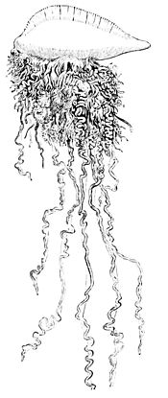

Portuguese Man O’ War = individual organisms working   
together for the good of the colonial organism.

Agile Project Team = Agile Project Teams working together with   
other Agile Project Teams for the good of the project.